NOTICE OF PUBLIC MEETING
City Council Meeting Minutes Thursday Sept 8th, 2022 @ 7:00 PM City Hall - 103 E 1st St
The City Council of the City of Alburnett, Iowa met in regular session, Thursday, Sept 8th, 2022, at 7:00 pm at City Hall with Mayor Bethany Sarazin presiding. Sarazin called the meeting to order at 7:00 pm.
Following the Pledge of Allegiance, roll call was taken with the following council members present Joe Trumm, Dave Boesenberg, Chester Schantz, Chris Meyers. Council member TJ West was not present.
Approval of Agenda: Mayor Sarazin called for a motion to approve the agenda. Moved by Schantz second by Boesenberg. Motion Approved. All Ayes. West not present. (4) Motion Carried.
SHERIFF’S REPORT: Deputy Halverson was present. Noted required hours met of 43 hours and 16 calls for service.
MAYOR’S REPORT: Mayor Sarazin gave report, noting the following items: (A.) Special meeting from the 17th did not result in obtaining the firetruck. We had approved up to 50K. Fire truck went for 64k. B.) We should be expecting the new digital sign. Drafting a policy for posting information on the sign. C.) Next month we will be reviewing our capital improvement plan.
Council comments: Nothing to report from Trumm, Boesenberg, Schantz, or Meyers.
CITIZENS COMMENTS – Agenda related: None Non-Agenda related:
Linn County Rental. Speaker – Landlord property owner Mary Lou and Larry Martin was present: on topic Linn County Building Rental Inspection and Property Maintenance. Landlord owns rental property within Alburnett. She asked why we cannot use local inspection people for the Rental Inspection and Property Maintenance. She thought we had a building committee. We do not. She is concerned about bringing an outside agency like Linn County will create issues for landlords in the community.
WRITTEN REPORTS:
Fire Department – Chief Graham present. Nothing to add to report. Mayor: a.) congratulations on perfect attendance. b.) Who is providing flags for the new poles at the fire station? Steve stated this has not been determined yet.
Public Works Department: Guy Trimble present. Nothing to add. Sign up for IRWA in Dubuque Oct. 4th and 5th.
Clerks Report: Chris Shelby present. Nothing to add. Thanked Schantz, Boesenberg, Trumm for their assistance in cleaning up and organizing city hall.
CONSENT AGENDA: Approved minutes from previous agenda, list of bills Claims Report
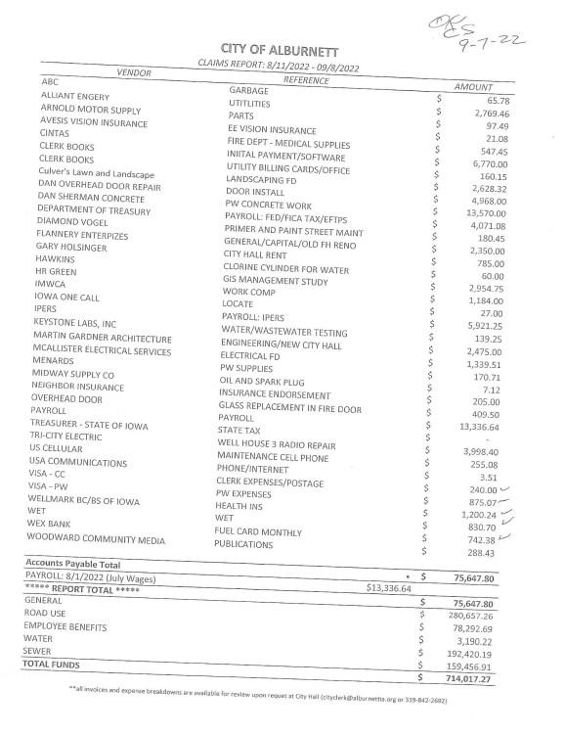

b. Flannery Enterprizes for city hall design work invoice.
Mayor Sarazin called for a motion to approve the consent agenda. Moved by Trumm second by Boesenberg. Motion Approved. All Ayes. West not present. (4) Motion Carried. List of bills and claims.
NEW BUSINESS:
- Temporary outdoor liquor license approval for Giveys – non special event. Mike Givens present. Mike stated that on Sept 24th, 2022, a local ATV ride coming in to the City of Alburnett at approximately 1pm. His establishment will only hold 50. Only needs permit for about an hour. About 300 people. No street closure. Drinking just outside the door’s permission only.

Moved by Schantz second by Trumm. Motion Approved. All Ayes. West not present. (4) Motion Carried.
- Discuss Holiday Committee and Lights
    - Discuss organization of committee
    - Request for 20,000 allocations general of funds for lights
One way to bring people to a town and increase new homeowner traffic is to have holiday lights and town presentations. Looking to have a day to honor Veterans of the town with banners. Council wants to see committee formed and action plan in place before approving any funding.
- Put Alert Iowa to put on website and social media. Council made aware and stated to continue forward with action.
No approval needed.
OLD BUSINESS:
- Discuss contract with Linn Building Department for rental inspections and property maintenance inspections.
Linn County present. Finalized checklist. Discussion regarding applying codes. Consistency across the board. Single inspector who knows the code book will conduct inspections. Discussion took place between Linn County and landlords present. Public Works added to discussion stating major reason for adding Linn County as an ally was to assist in enforcement of property maintenance and inspections with a single inspector. Mayor emphasized ease in having one single list for inspection. Mayor stated we will have to adopt proposed maintenance code and housing code into our codes. Ordinance revision and 28E needed. Motion to move forward with Linn County Building Property Maintenance and Rental Inspections.
Moved by Meyers second by Boesenberg. Motion Approved. Meyers, Trumm, Boesenberg Aye. Schantz – Nay. West not present. (4) Motion Carried.

- Discuss website hosting and support. Dreamhost and Siteground reviewed with GoDaddy. GoDaddy provides all services all in one solution with customer support. Motion to move forward with GoDaddy for hosting and support.
Moved by Meyers second by Trumm. Motion Approved. All Ayes. West not present. (4) Motion Carried.
FINAL COMMENTS/DISCUSSION: Dave Boesenberg, Meyers, Chester Schantz, Joe Trumm all saying nothing to add. Council member West was not present.
MOTION TO ADJOURN:
Moved by Trumm second by Boesenberg. Motion Approved. All Ayes. West not present. (4) Motion Carried.

